**JMeter Request**

Here we have 2 thread group 1 for Wikipedia and second for search result

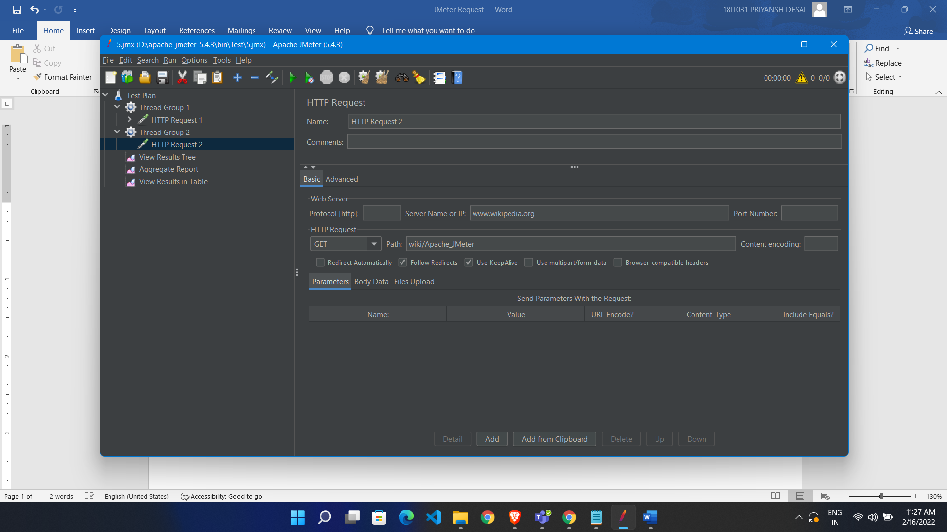

We make thread1 to run for 10 sec and thread 2 also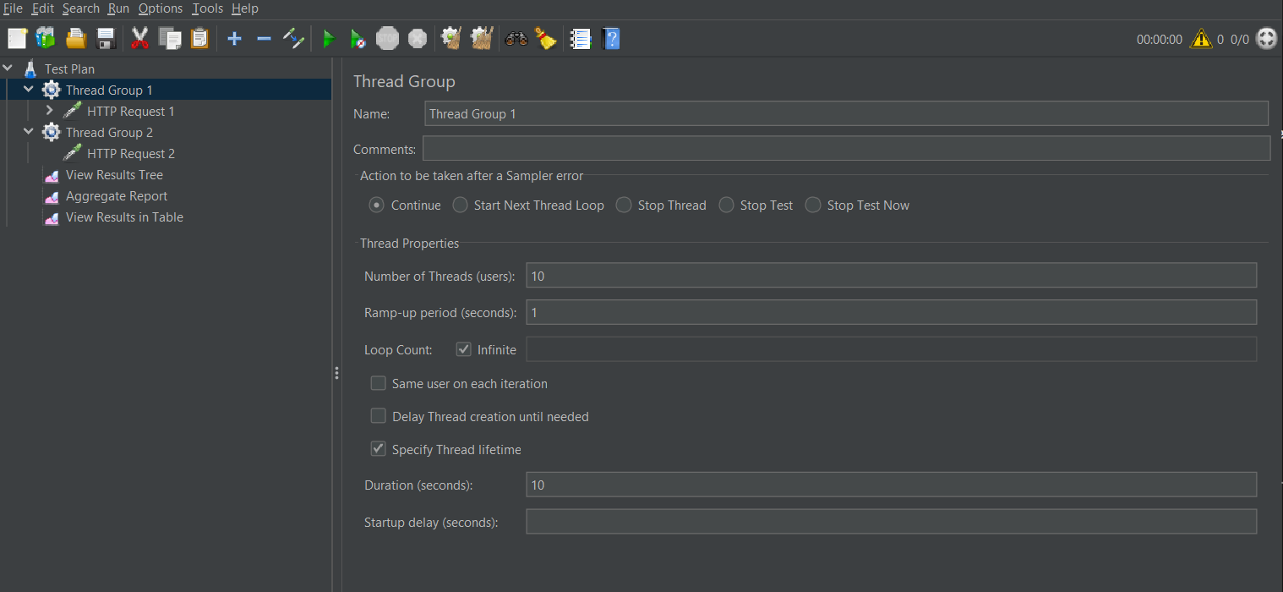

Now we make sequential request for both means after complete thread1 then thread 2 run

* Go to test plan
* Check run thread group consecutively

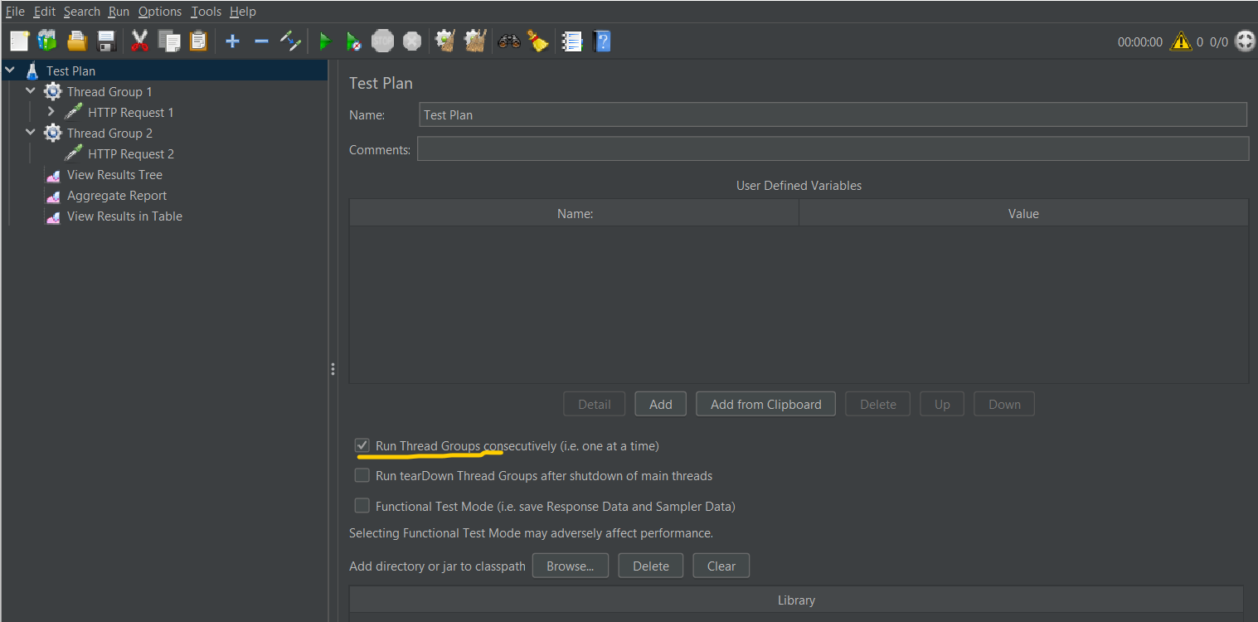

So result is thread1 run for 10 sec and then thread2 start

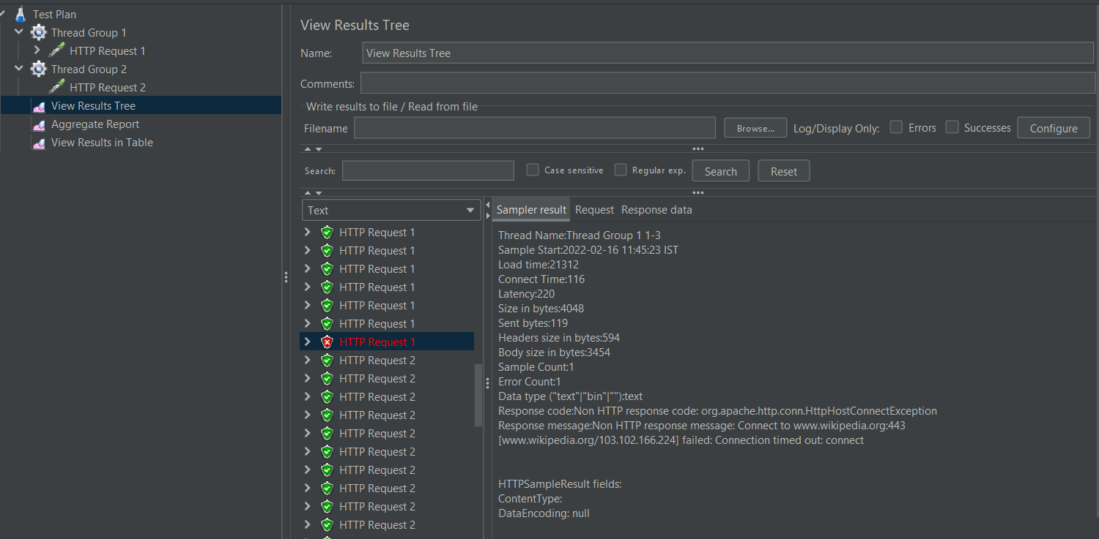

Parallel Request:

* First, we have to add plugin manager to jmeter
* <https://jmeter-plugins.org/install/Install/> download from here (JAR file)
* Pate it in lib/ext

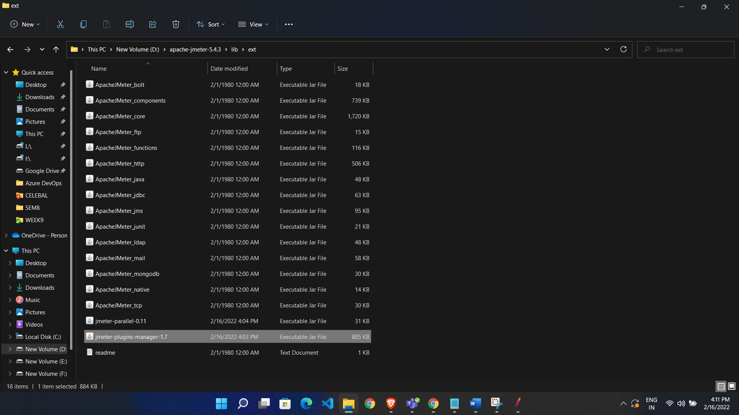

Add custom thread group plugin:

* In JMeter go to option
* Click plugin manager
* Add plugin

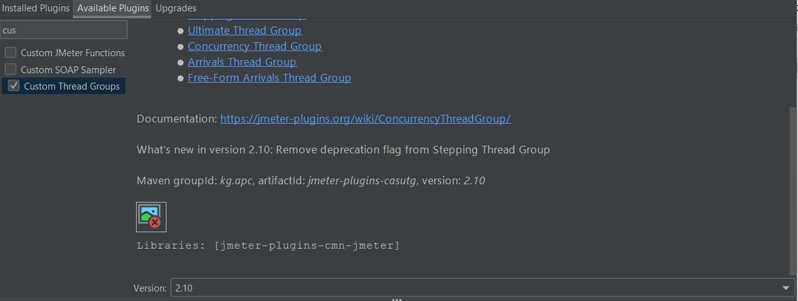

* Target concurrency = 10 (num of thread)
* Set ramp up period (we have time on x-axis and time on y-axis)

